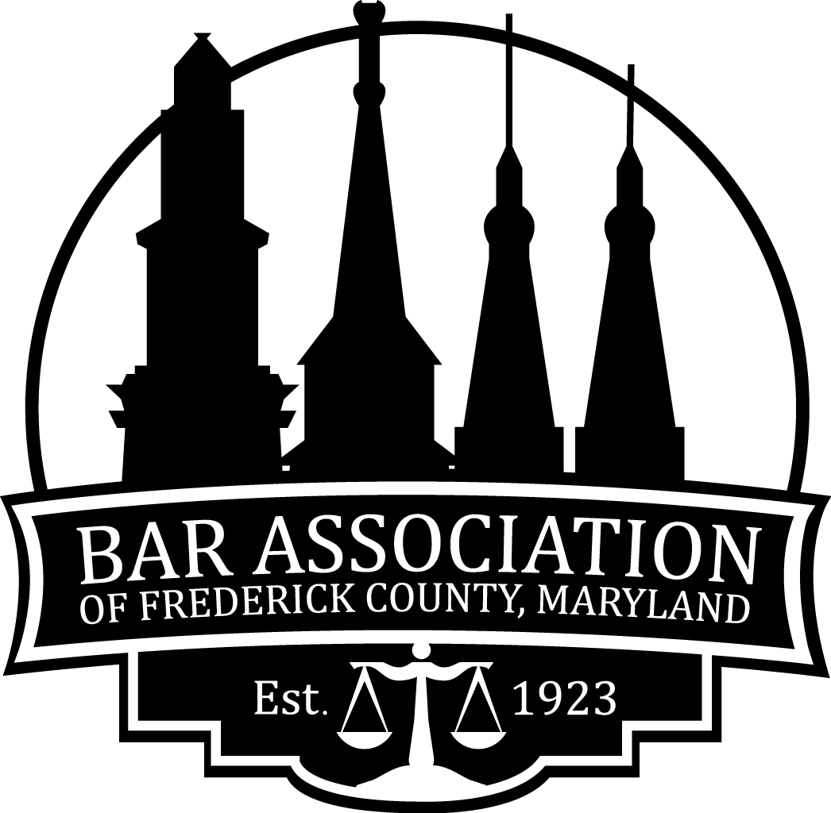
The Bar Association of Frederick County, Maryland
P.O. Box 3088 • Frederick, Maryland 21705 • www.frederickbar.org • Phone 240-285-9660

2025 Sponsorships with the BAFC
Website Sponsorship: $1050 for 12 months; $625 for 6 months
As a website sponsor you receive:
- Company logo placed on the main BAFC website and hyperlinked to company’s home page.
Monthly Meeting Sponsorship (Virtual or In-Person*): $300
With a meeting sponsorship you receive:
- Recognition as the meeting sponsor in a minimum of 2 emails sent to members announcing the event;
- Up to 2 minutes to talk about your services either “live” or in a pre-recorded “commercial;”
- A vendor table in the meeting room to display your services and any promotional items
- A “thank you” post with picture and webpage displayed on our facebook page after the meeting
- If your sponsored month is one in which we meet in person, you will also receive a free catered or boxed lunch* for up to 2 members from your organization.

The Bar Association of Frederick County,
Maryland
P.O. Box 3088 • Frederick, Maryland 21705 • www.frederickbar.org • Phone 240-285-9660

Sponsorship Contract 2025
Date:
Advertiser:
Contact Name:
Address:

Telephone:
Email:
Requested Sponsorship:

Artwork:
Artwork for the newsletter advertisements should be emailed in jpeg format to info@frederickbar.org.
Payment:
Payment must be received on or before the date of the sponsorship.
Newsletter advertisements will be placed in the best possible format for both the newsletter and the advertiser. The advertiser agrees to hold harmless the publisher for the publication of submitted copy. The BAFC will not be responsible for errors in advertising after this agreement is signed. Cancellations will not be accepted after signing the contract. All copy in subject to approval. Advertisers acknowledge receipt of and agree to the terms and conditions included in this publication. The BAFC is hereby authorized to list my business as a sponsor and include our advertisement in the BAFC electronic newsletter.

_______________________________ __________________________________
Signature of Sponsor Signature of BAFC Representative

